**WAGNER—**Letter K – Fermata (Allegro con brio)

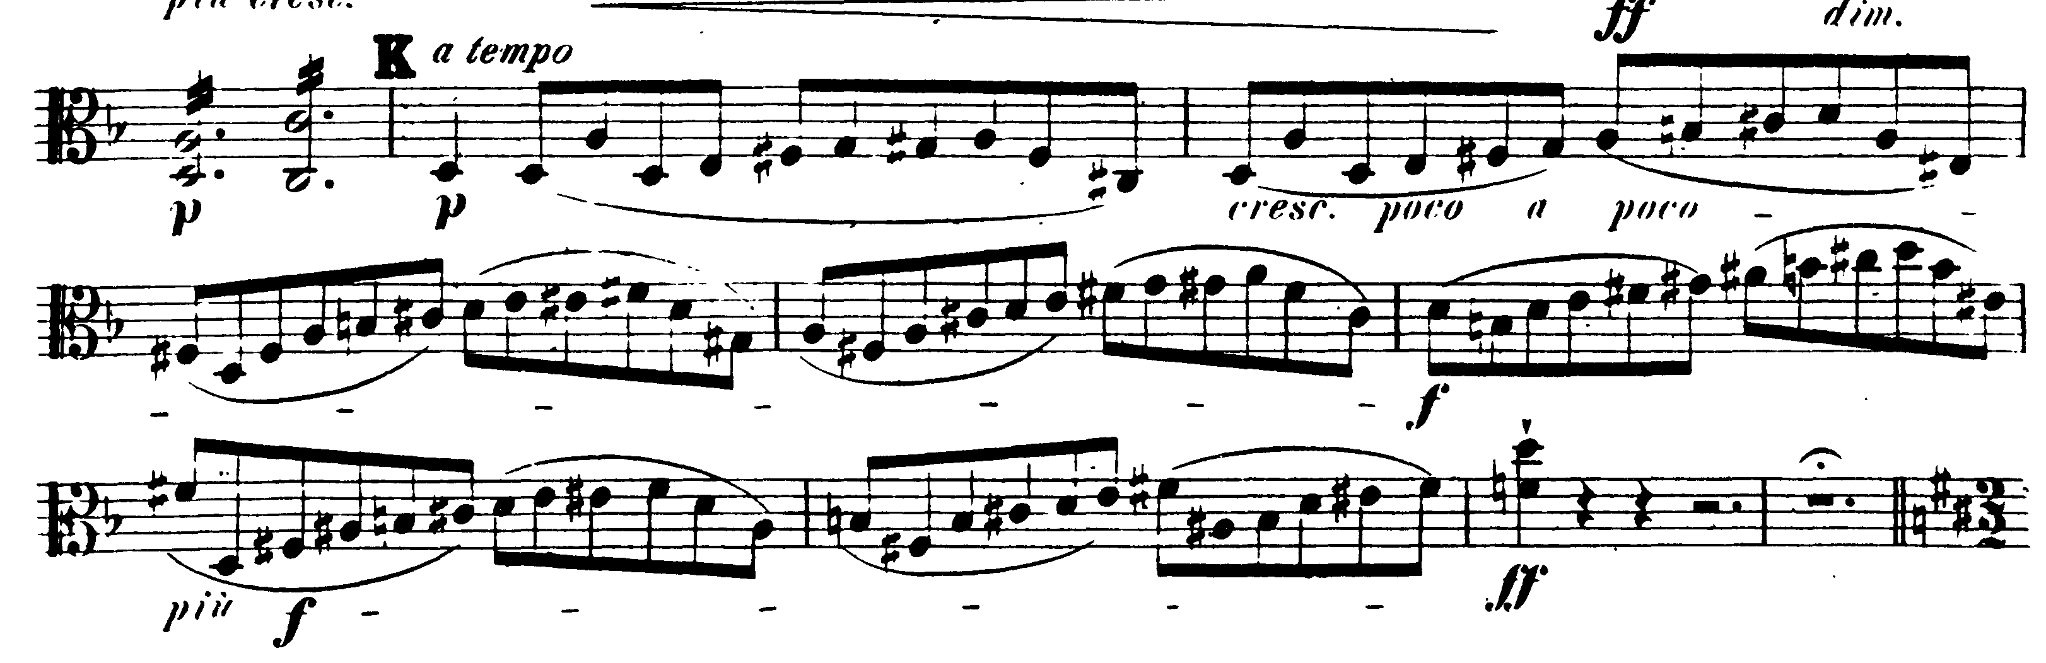

6/4 meter – 2/2 meter

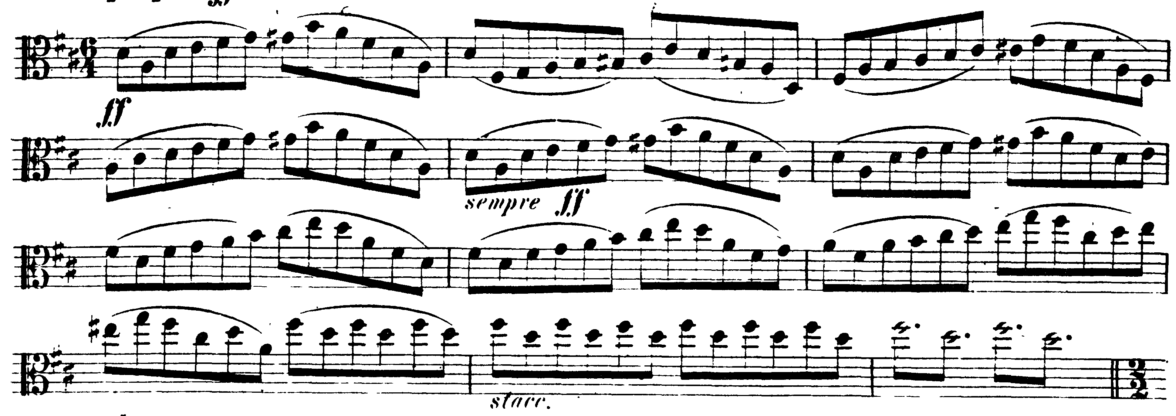

**TCHAIKOVSKY—**Mvt III: pick-up 135 – 144 (Allegro valse)

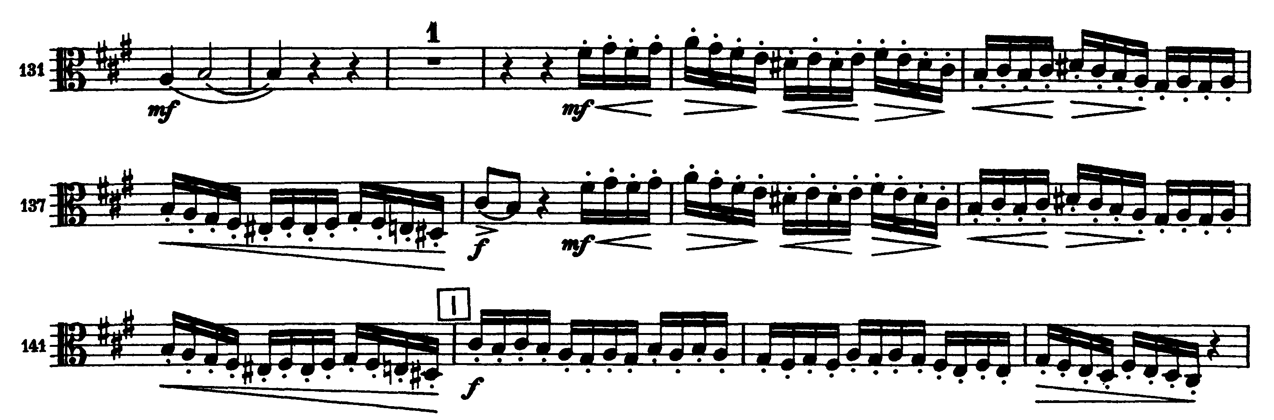

Mvt IV: Presto – Molto meno mosso



